# Frontend Development with React.js

# Store Management:Keep Track of Inventory

# Introduction:

# **Project Title:** Store Management:Keep Track of Inventory

# **Team Members:**Mahalakshmi, Shafrin, Swarnalatha, Tharika, Sivaranjini

# **Project Overview:**

# **Purpose:** Store management is the process of handling and controlling all activities related to a store. It involves organizing, maintaining, and monitoring items to ensure they are available when needed and used efficiently.

# **Features:**

# **Tracking** – Keeps record of all items in the store.

# **Receipt & Issue Management** – Tracks items coming in and going out.

# **Stock Control** – Maintains proper stock levels to avoid shortages or excess.

# **Organized Storage** – Arranges items neatlyfor easy access

# **Security** – Protects items from theft, loss, or damage

# **Record Keeping & Reporting** – Maintains accurate data and generates reports.

# **Cart Management** – Allows adding selected items to a cart for easy checkout or issue.

# **Component Structure:**

# **Navigation Bar Component:**

# Located at the top (Home, Basket, Inventory, Sales, Add Products).

# Provides routing between different pages.

# Includes Store Logo/Name (A-Z Store).

# **Search Bar Component:**

# Allows users to search for products in the catalog.

# Placed under the header “Product Catalog.”

# **Product Catalog Component:**

# Displays the list of all products available in the store.

# Each product is shown using a Product Card Component.

# **Product Card Component:**

# Each card contains:

# Product Image (sample item, sunflower oil, Dark Fantasy, etc.).

# Product Name.

# Price Information.

# Add to Cart Button.

# **Cart Component:**

# Handles items added to the cart.

# Shows total items, total price, and checkout option.

# **Inventory Management Component:**

# Allows admin to add, update, or delete products.

# Accessible via “Inventory” or “Add Products” menu.

# **Sales/Report Component:**

# Displays sales data and reports.

# Helps track store performance.

# **Footer / Status Bar Component:**

# Shows additional info (example: weather, time, system notifications).

# In a web app, it could include support info or copyright details.

# **State Management:**

# Cart state (items added, removed, total price).

# Inventory state (products available, stock levels).

# User session state (login/logout).

# **Routing:**

# /basket → Cart page

# /inventory → Inventory management

# /sales → Sales reports

# /add-products → Add new items

# /store → Product catalog (homepage)

# **Setup Instructions:**

# **Prerequisites:**

# We need node.js, VS code, react.js to run and edit our project

# Then we need to install npm in the terminal using “npm install” command

# **Running the Application:**

# Provide commands to start the frontend server locally.

# **Frontend:**

# npm start in the client directory.

# **User Interface:**

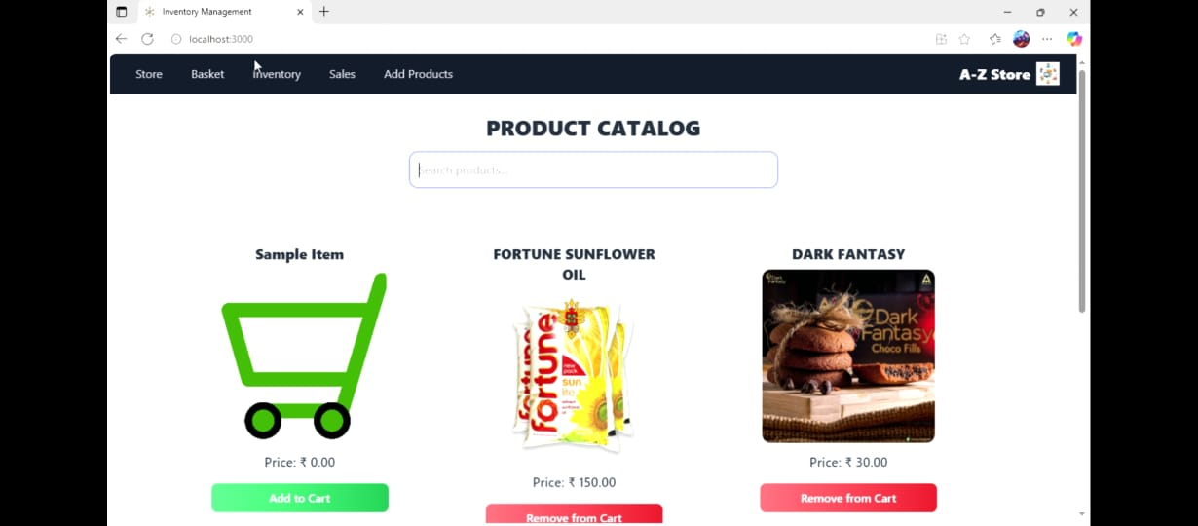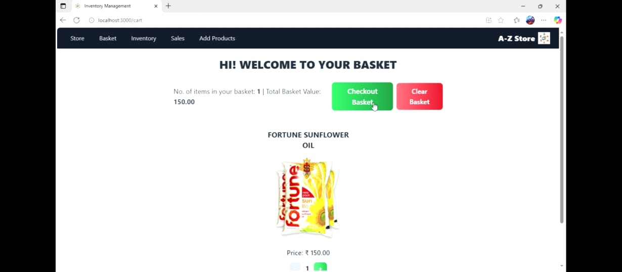

# **Future Enhancements:**

# **Navbar & Navigation:**

# **Sticky Navbar** → stays on top while scrolling (sticky top-0 z-50).

# **Modern Colors** → darker background (bg-gray-900) with subtle shadow.

# **Navigation Links** → rounded, padded, and animated hover transitions.

# **Mapped Links** → cleaner DRY code using an array.

# **Brand Section** → added InventoryPro style with green accent for modern branding.

# **Logo Styling** → drop-shadow-sm for subtle depth.

# **Forms & Inputs:**

# Card Styling → rounded 2xl, shadow, and hover scale for a smooth modern effect.

# Form Fields → consistent p-3 inputs with stronger focus ring (focus:ring-green-400).

# Dynamic rendering → used an array map to render fields → cleaner + DRY.

# Button → bold, modern with active:scale-95 for click feedback.

# Emoji in title (✚) → adds friendliness to the UI.

# Alerts → now shows ✅ check emoji for success.

# **Inventory & Product Cards:**

# Product Cards redesigned with modern rounded styling, hover effects, and balanced spacing.

# Inventory Cards improved with cleaner grid alignment and better typography.

# Consistent shadows and padding applied for uniform look across cards.

# **Cart Page:**

# Cart layout modernized with cleaner table structure and hover row effects.

# Buttons updated to match bold modern theme with subtle animations.

# Alerts added for cart actions with success/error indicators.

# **Sales Dashboard:**

# Container: centered with max-w-5xl mx-auto → looks neat on wide screens.

# Heading: larger, bolder, and added 📊 emoji for a modern dashboard vibe.

# Grid layout: now responsive → 1 column on mobile, 2 on tablets, 3 on desktops.

# Empty state: friendlier with a small subtext + emoji instead of plain text.

# Spacing: more balanced padding (p-6, gap-6, mt-12).

# **Styling & Branding Enhancements:**

# Consistent use of modern emojis across titles for friendliness.

# Shadows and hover effects added globally for interactive feel.

# Typography unified with bold headings and clean readable body text.

# Balanced padding and spacing applied to all major components.

# **Demo Video Link:**

[Demo Video-Store Manager.mp4](https://1drv.ms/v/c/544e8530b72a0bd5/EbB7OWgK-stGoSoskkDV_0MBs3NzkJao23mYcugtZs77xQ?e=mfD1hh)